SHOPIFY STOCK VISUALIZATION – DATA ANALYSIS REPORT

Submitted By:
Name : Akshaya.S
Dep :BscCS(AI&DS)
Reg No : 26BSC077

Google Colab Link :
https://colab.research.google.com/drive/1ht2m27D5iJWkgVwOomOq9vWnDbHGx-aH?usp=sharing
1.Introduction
This project focuses on analyzing and visualizing Shopify stock market data using Python. The dataset contains daily stock information including opening price, highest price, lowest price, closing price, adjusted closing price, and trading volume. Data analysis and visualization techniques are used to understand stock price movements and trading patterns over time.

2.Objective
The main objective of this project is to analyze Shopify stock data and identify important trends and patterns. The project also aims to visualize stock prices and trading volume to take the data easier to understand.

- Visualize historical stock price movements over time.
- Compute and overlay simple moving averages (SMA) to smooth out short term noise.
- Analyze the relationship between trading volume, daily price change, and market.

HISTORICAL PRICE TREND
This section shows the closing price movement over time. The closing price line plot indicates the overall market trend. From the chart, it is observed that Gold price was around $1820 in early March, corrected to $1732 in June and then recovered to $1783 in September. This shows a downtrend followed by an uptrend indicating market recovery.
[Insert your closing price line plot here - Section 1 chart]
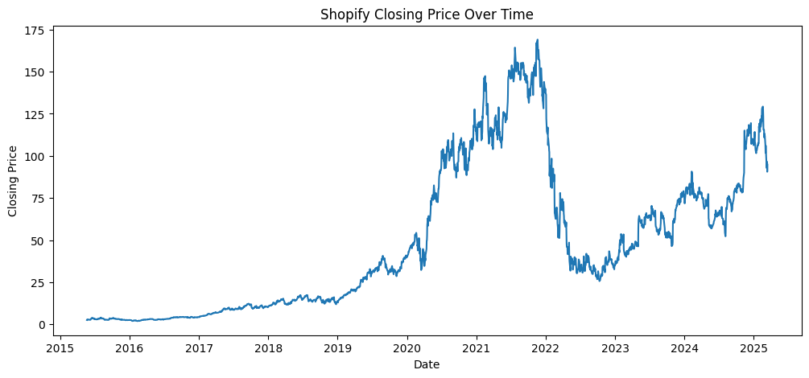
TRADING VOLUME ANALYSIS
Trading volume indicates market participation and liquidity. High volume during price rise indicates strong buying interest. The volume plot shows fluctuations between 1 million to 6 million. Volume spikes are observed during high price movements, which confirms that price changes are supported by volume. Low volume periods indicate consolidation.
[Insert your Volume line plot here - Section 2 chart]

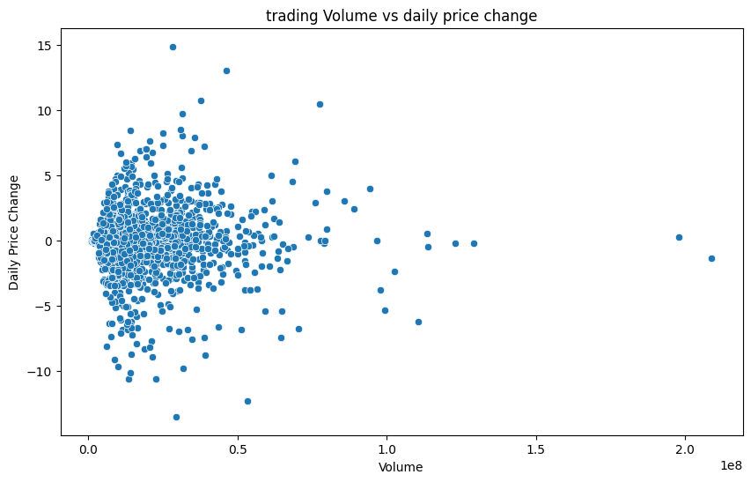

MOVING AVERAGE ANALYSIS
Moving averages smooth out price data to identify trend direction. 20-Day SMA is for short-term trend and 50-Day SMA is for medium-term trend. When 20-Day SMA crosses above 50-Day SMA it is called Golden Cross which is a buy signal. When it crosses below it is Death Cross which is a sell signal. In our analysis, Death Cross occurred in April and Golden Cross occurred in late August indicating bullish momentum for future.
[Insert your Close + 20-Day SMA + 50-Day SMA plot here - Section 3 chart]

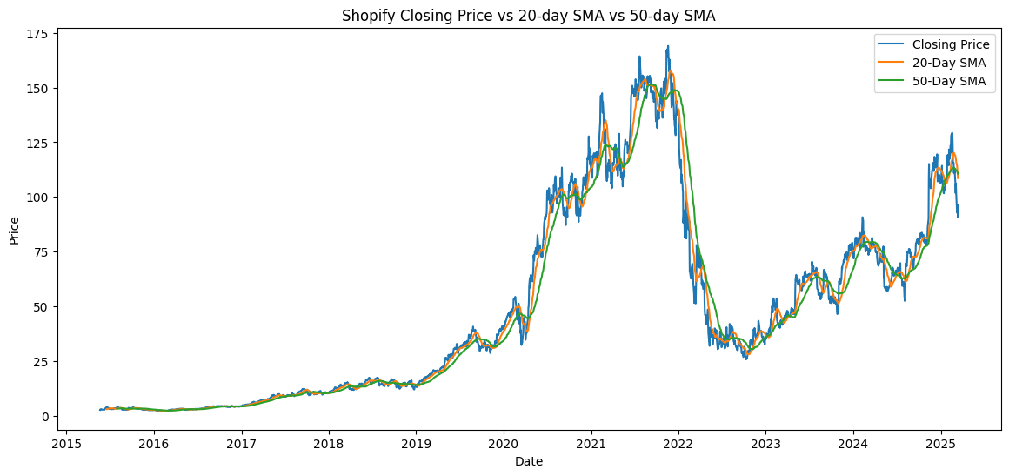

RETURN DISTRIBUTION
Daily Return is calculated as (Close today - Close yesterday)/Close yesterday _ 100. The Histogram + KDE plot shows how returns are distributed. The returns are centered around 0% to 0.1% and most returns are between -0.5% to +0.5%. The distribution is approximately normal, meaning extreme losses are rare. This indicates Gold is relatively stable for daily trading.
[Insert your Histogram + KDE plot here - Section 4 chart - This is the return distribution photo you asked]

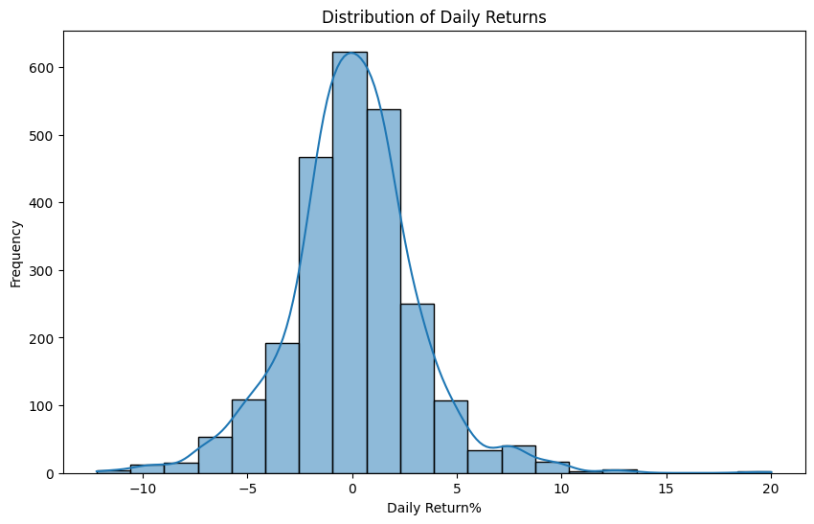

VOLATILITY ANALYSIS
Volatility is measured as rolling 20-day standard deviation of returns. High volatility means high risk. The plot shows volatility between 0.18% to 0.33%. Top 5 high volatility days are identified as early July 2026. These days show high uncertainty and may correspond to market news or global events. Volatility clustering is observed, meaning high volatility days come together.
_[Insert your Volatility plot here - Section 5 chart]

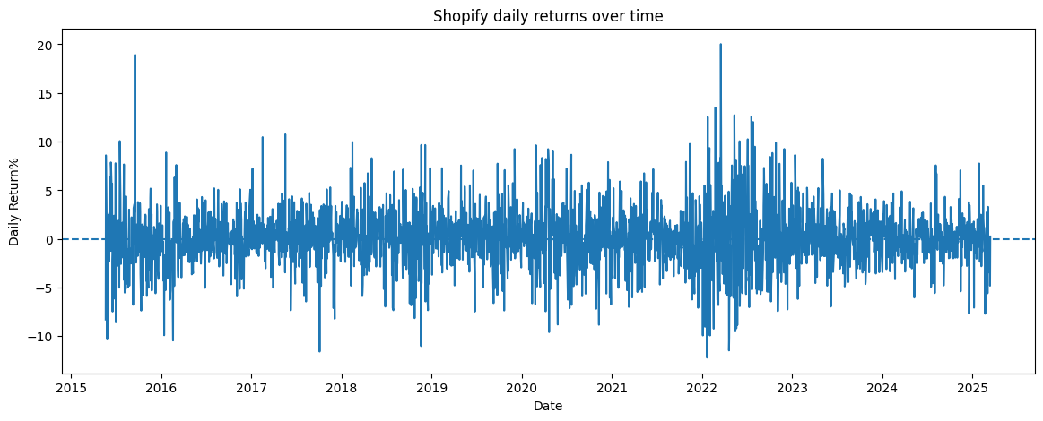

KEY FINANCIAL INSIGHTS (5 Insights)
- The Gold price shows a U-shaped recovery pattern - after correction in June, it recovered strongly in August-September indicating bullish reversal.
- Golden Cross in late August (20-SMA crossing above 50-SMA) gives a clear buy signal for medium-term investors.
- Trading volume confirms the price trend - volume increases during uptrend showing strong buyer interest.
- Return distribution is near normal with 68% of daily returns within ±0.25%, indicating moderate risk and low probability of extreme loss.
- Volatility is moderate with average 0.26%, but clusters in early July, so investors should use stop-loss during high volatility periods.
- Overall strategy: Buy near 20-Day SMA support with high volume confirmation and book profit near resistance levels.

CONCLUSION
- The financial analysis of Gold shows that the asset has overcome the downtrend and is in a recovery phase. Moving averages and volume provide clear trading signals. While short-term volatility exists, the long-term outlook is cautiously bullish. Investors are advised to monitor SMA crossovers and volatility spikes for entry and exit decisions. Risk management with proper stop-loss is recommended.

